Database File Generator

- Open “Database_Maker.xlsm”
- A security dialog box should appear beneath the Office ribbon you attempt to run a spreadsheet that contains macros.
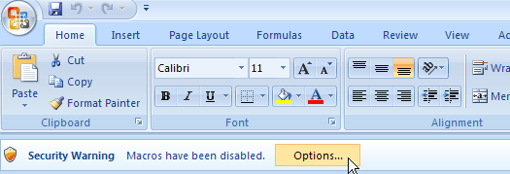
- When the notification appears, click the Options button. Choose Enable this content from the options that appear to allow macros to run within the current spreadsheet. Click OK to close the window.
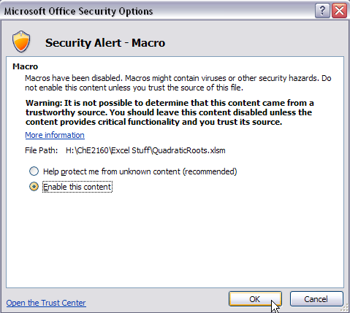
- Input your data in current spreadsheet. (First column is index)
- Select all of your data. (for example)
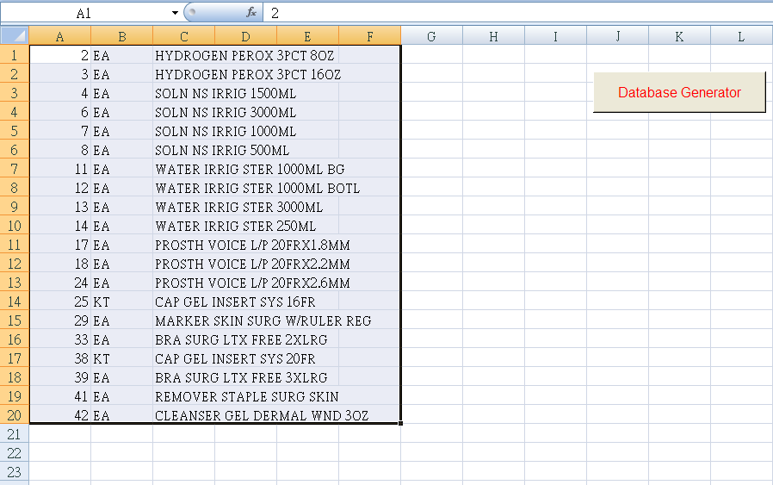
- Press “Database Generator” button.
- The “database.txt” should be created in the same Database_Maker.xlsm directory.
- Download the database file by Print Utility.
